# Class 8

# User Interface

Let’s create a new project and start with the third person shooter game. You will see all the blueprints and configurations already build inside that.

For creating the User Interface, first create the empty level.

Save the level named as level1 by clicking on File -> Save Current

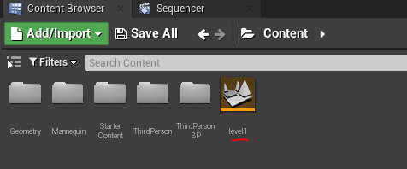

Your user interface level and your actual game level both are different.

Right Click and create the game mode base.

Now, configure the HUD by right click and select the blueprint class

Create the user interface:

From there

You can drag and drop the image and then you can use them inside the UI.

Your UI looks like this

Now, we can do the screen size and other factor inside that.

CTRL + SHIFT to update the anchor inside the canvas.

Brush and then you can input the image there.

Make sure you put the texture, not the material inside the canvas.

Let’s put a texture on it.

Various button effects like hover, clicked and disabled.

Change your default game mode to the one which you created earlier.

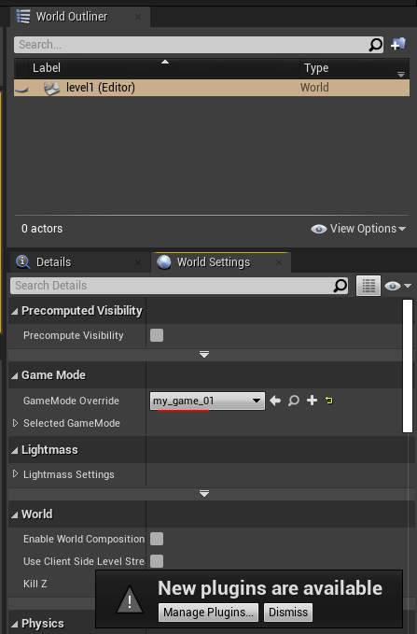

And now open the game mode which you created and then reference the HUD on that.

Then open the HUD and then reference the UI which we created earlier.

Now you need to provide the viewport and player owner to this node.

And let say sometimes you have an option to hide and unhide the cursor depending on the game you are developing.

Now, Let’s add the functionality which handles that play and quit functionality.

